JWT

THERE are 3 parts in a jwt

You can go to jwt.io website

we can play around with jwt here.

Now we will create a jwt application as below

Make a controller

Now do authentication as shown below.write the configure method

The below service will return us a user object

Now we will add a password encoder

Now we will add a jwt

Add the above dependency

Now we will make a jwtUtil class

Now we will make below endpoint

We make class as below:

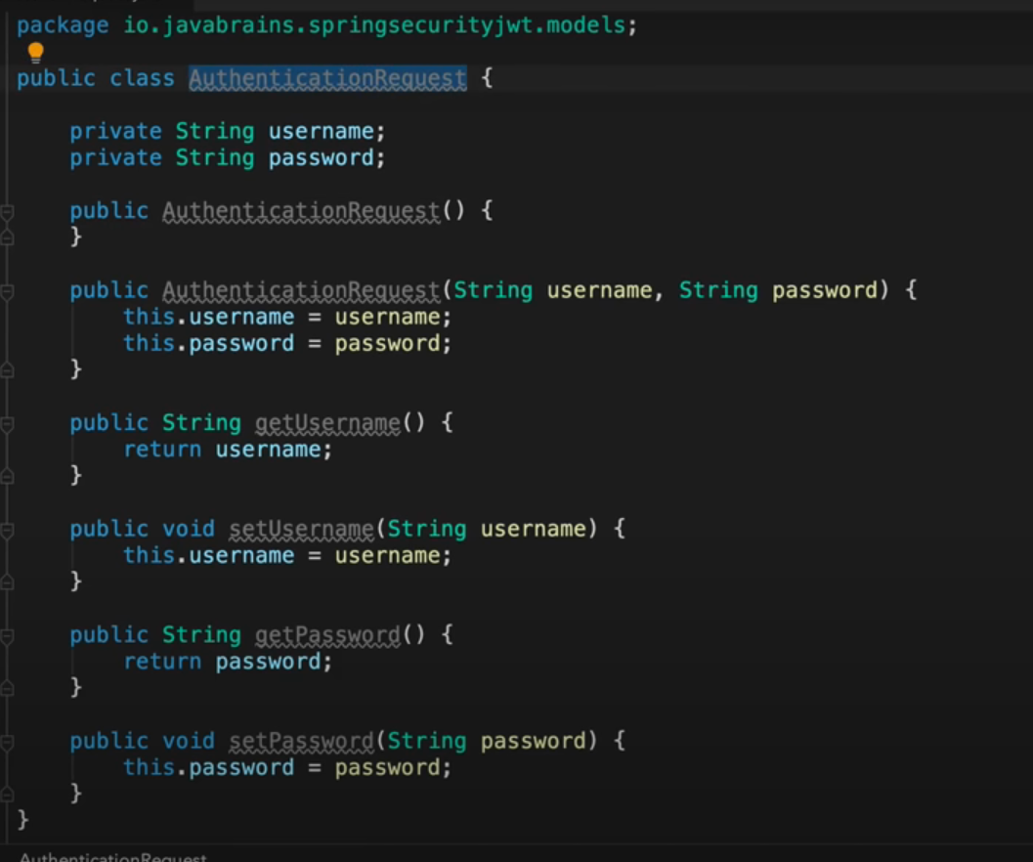

Make an authentication response as can be seen below:

